**Industrial Internship Report on**

**”Url shortener using python”**

**Prepared by**

Abhimanyu Singh

|  |
| --- |
| *Executive Summary* |
| This report provides details of the Industrial Internship provided by upskill Campus and The IoT Academy in collaboration with Industrial Partner UniConverge Technologies Pvt Ltd (UCT).  This internship was focused on a project/problem statement provided by UCT. We had to finish the project including the report in 6 weeks’ time.  My project was based on making a working model of url shortener using python and its libraries.  This internship gave me a very good opportunity to get exposure to Industrial problems and design/implement solution for that. It was an overall great experience to have this internship. |

**TABLE OF CONTENTS**

1 Preface 3

2 Introduction 4

2.1 About UniConverge Technologies Pvt Ltd 4

2.2 About upskill Campus 8

2.3 Objective 9

2.4 Reference 10

2.5 Glossary 10

3 Problem Statement 11

4 Existing and Proposed solution 11

5 Proposed Design/ Model **Error! Bookmark not defined.**

5.1 High Level Diagram (if applicable) **Error! Bookmark not defined.**

5.2 Low Level Diagram (if applicable) **Error! Bookmark not defined.**

5.3 Interfaces (if applicable) **Error! Bookmark not defined.**

6 Performance Test 12

6.1 Test Plan/ Test Cases 12

6.2 Test Procedure 12

6.3 Performance Outcome 12

7 My learnings 13

8 Future work scope 14

# Preface

Summary of the whole 6 weeks’ work.

About need of relevant Internship in career development.

Brief about Your project/problem statement.

Opportunity given by USC/UCT.

How Program was planned

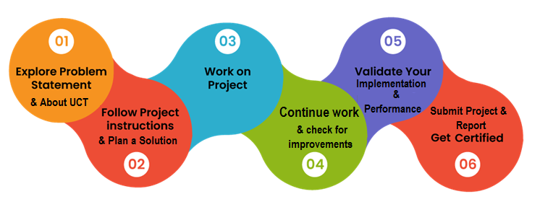

Your Learnings and overall experience.

Thank to all (with names), who have helped you directly or indirectly.

Your message to your juniors and peers.

# Introduction

## About UniConverge Technologies Pvt Ltd

A company established in 2013 and working in Digital Transformation domain and providing Industrial solutions with prime focus on sustainability and RoI.

For developing its products and solutions it is leveraging various**Cutting Edge Technologies e.g. Internet of Things (IoT), Cyber Security, Cloud computing (AWS, Azure), Machine Learning, Communication Technologies (4G/5G/LoRaWAN), Java Full Stack, Python, Front end**etc.

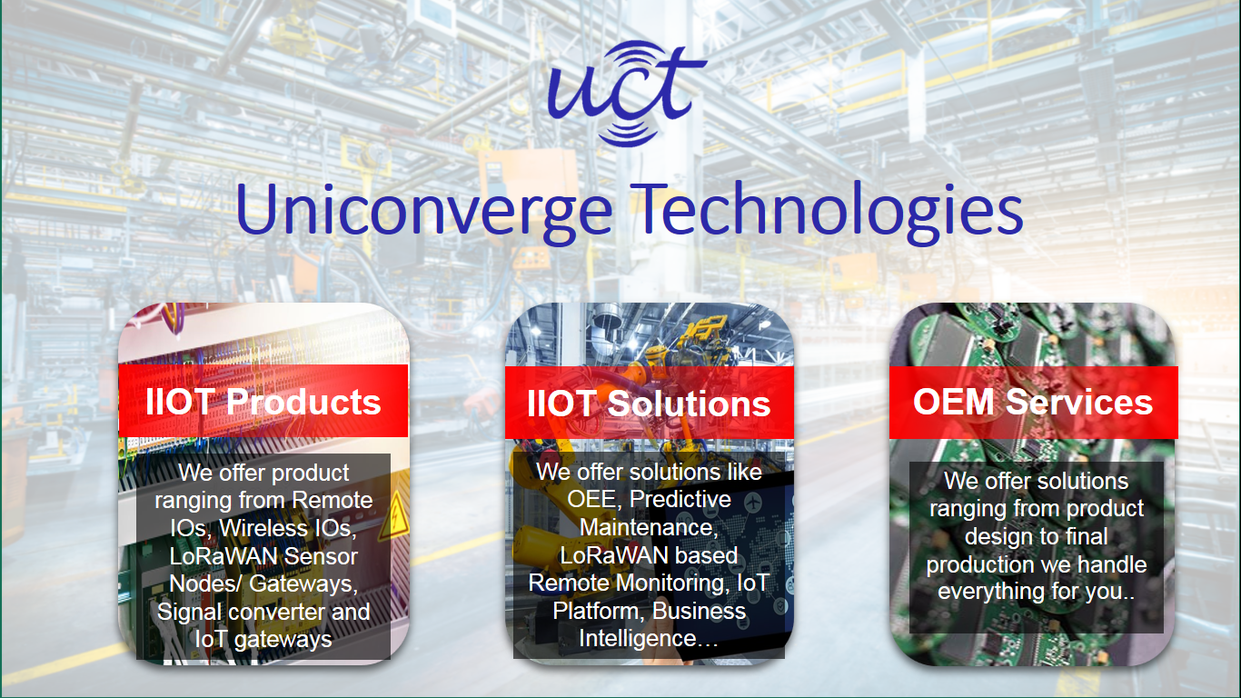

1. UCT IoT Platform **(****)**

**UCT Insight** is an IOT platform designed for quick deployment of IOT applications on the same time providing valuable “insight” for your process/business. It has been built in Java for backend and ReactJS for Front end. It has support for MySQL and various NoSql Databases.

* It enables device connectivity via industry standard IoT protocols - MQTT, CoAP, HTTP, Modbus TCP, OPC UA
* It supports both cloud and on-premises deployments.

It has features to  
• Build Your own dashboard  
• Analytics and Reporting  
• Alert and Notification  
• Integration with third party application(Power BI, SAP, ERP)  
• Rule Engine

 

1. **Smart Factory Platform (****)**

Factory watch is a platform for smart factory needs.

It provides Users/ Factory

* with a scalable solution for their Production and asset monitoring
* OEE and predictive maintenance solution scaling up to digital twin for your assets.
* to unleased the true potential of the data that their machines are generating and helps to identify the KPIs and also improve them.
* A modular architecture that allows users to choose the service that they what to start and then can scale to more complex solutions as per their demands.

Its unique SaaS model helps users to save time, cost and money.

 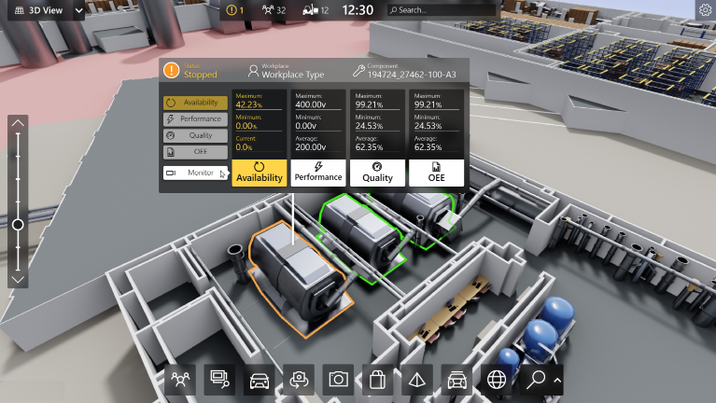

1. 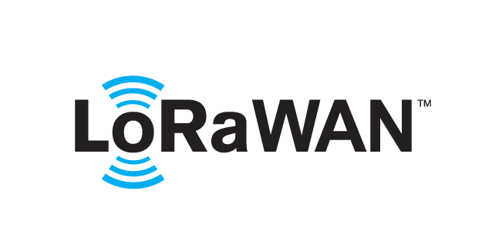 based Solution

UCT is one of the early adopters of LoRAWAN teschnology and providing solution in Agritech, Smart cities, Industrial Monitoring, Smart Street Light, Smart Water/ Gas/ Electricity metering solutions etc.

1. Predictive Maintenance

UCT is providing Industrial Machine health monitoring and Predictive maintenance solution leveraging Embedded system, Industrial IoT and Machine Learning Technologies by finding Remaining useful life time of various Machines used in production process.



## About upskill Campus (USC)

upskill Campus along with The IoT Academy and in association with Uniconverge technologies has facilitated the smooth execution of the complete internship process.

USC is a career development platform that delivers **personalized executive coaching** in a more affordable, scalable and measurable way.



Seeing need of upskilling in self paced manner along-with additional support services e.g. Internship, projects, interaction with Industry experts, Career growth Services

<https://www.upskillcampus.com/>

upSkill Campus aiming to upskill 1 million learners in next 5 year

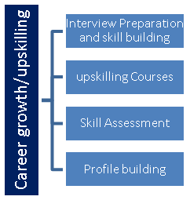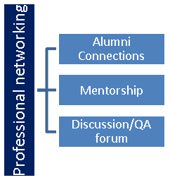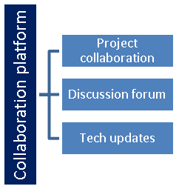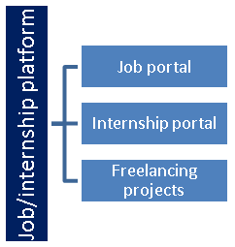

## The IoT Academy

The IoT academy is EdTech Division of UCT that is running long executive certification programs in collaboration with EICT Academy, IITK, IITR and IITG in multiple domains.

## Objectives of this Internship program

The objective for this internship program was to

 ☛ get practical experience of working in the industry.

 ☛ to solve real world problems.

 ☛ to have improved job prospects.

 ☛ to have Improved understanding of our field and its applications.

 ☛ to have Personal growth like better communication and problem solving.

## Reference

[1] Geeks for Geeks

[2] UpskillCampus and Uct support materials

[3] Advanced python programming by Quan Nguyen

## Glossary

|  |  |
| --- | --- |
| Terms | Acronym |
| Uct | Uniconverge Technologies |
| def | Define (built in function) |

# Problem Statement

In the assigned problem statement

My problem statement can be described in the following manner

Project Name- Url shortener using python

This projects required me to code a python file which could produce a tiny Url or shortened Url given a long Url as input by the user.

I had to analyse and come up with a very convincing code to make this happen.

# Existing and Proposed solution

There were a few attempts to resolve this problem by some but those resolutions had some limitations as well.

They were very huge sects of code and without much detailing about the process.

I have made some notable changes in the code .

For instance , I have made it more optimal in terms of processing speed and power requirements.

My focus was to provide a very optimized code for this problem.

## Code submission (Github link)

https://github.com/abhimanyusingh1860/upskillCampus-/blob/main/url_shortener_gui.py

## Report submission (Github link) :

https://github.com/abhimanyusingh1860/upskillCampus-/blob/main/ABHI%20PROJECT%20REPORT.pdf

# Performance Test

Url shorteners are the need of the hour.

Many attempts have been made to fulfill this requirement but still there are some limitaions in those models.

I have tried to resolve some of those limitations such as the processing power required and the speed of processing.

## Test Plan/ Test Cases

I analysed some of the already made models and then compared it with my model.

## Test Procedure

I performed the testing on 3 major parameters –

* The speed of processing using process time .
* The power requirement using cpu usage details.

## Performance Outcome

* I have analysed my project to be slightly faster than reference models which could also industrially be adapted.
* I have found that my project can work fine with processing powers as low as 1.0Ghz where as many reference projects required more than 2Ghz of processing power.

# My learnings

I started with analysing my problem statement . I build strong conceptual clarity on the python fundamentals and then tried implementing them over time.

I faced many challenges during this process but thanks to the abled guidance of my mentors that I could come up with satisfactory results.

I learned to code up many new scenarios and to understand third party softwares like github as well.

Overall , my experience was very good in terms of learning opportunities and mentor ship availability.

# Future work scope

I would like to work further in the same field of url shortening by using advanced python skills such as its collaboration with machine learning and artificial intelligence.

Hoping for good future opportunities under the abled team of upskillCampus and uct.